CH – 3

In this chapter I learned how to use jQuery for making input buttons, use different div data roles and make mobile websites by using jQuery frameworks. I also learned how to use javascript functions to change the value of an html element.

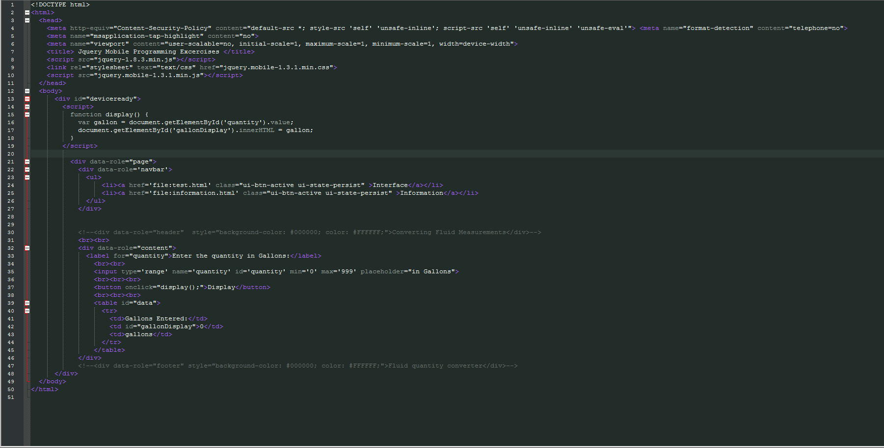

Figure 1 Html Code behind the Website

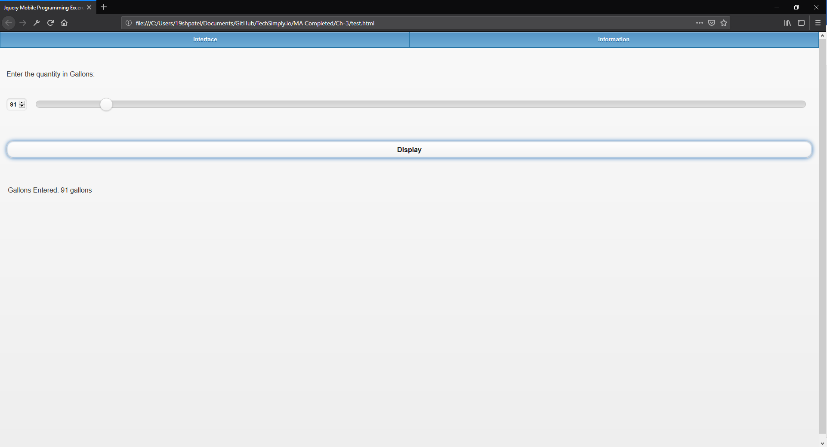

Figure 2 The website

Ch-4

In Chapter 4 I learned how to put restrictions on input radio buttons, how to make conversion methods in javascript, make math equations in javascript, make arrays in javascript and find distance between two arrays, and how to use javascript and node.js to make command line interface programs and how to output them into an html file.

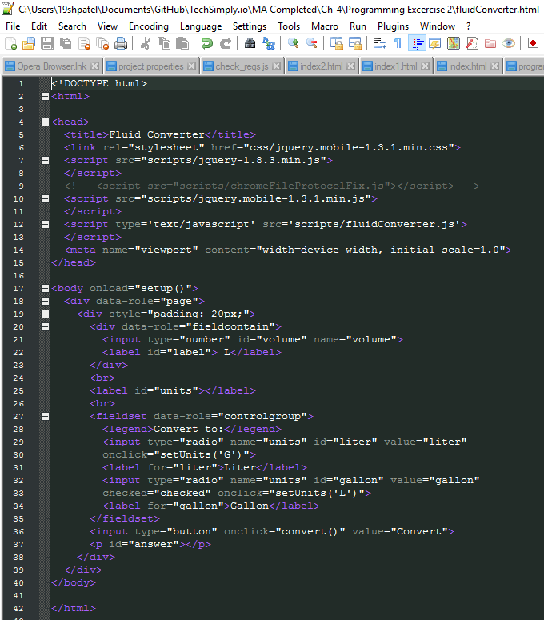

Figure 3 Validation html code

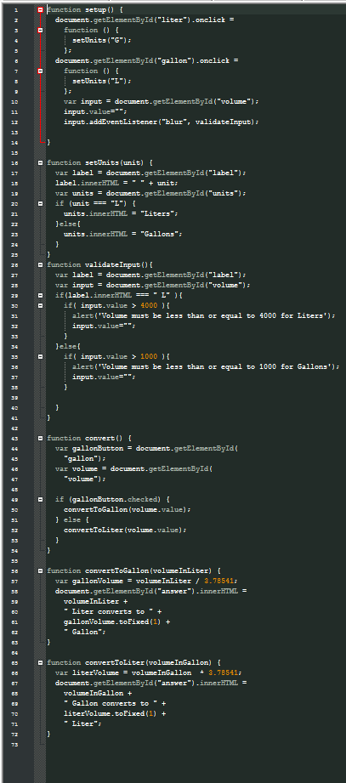

Figure 4 Validation Function Javascript

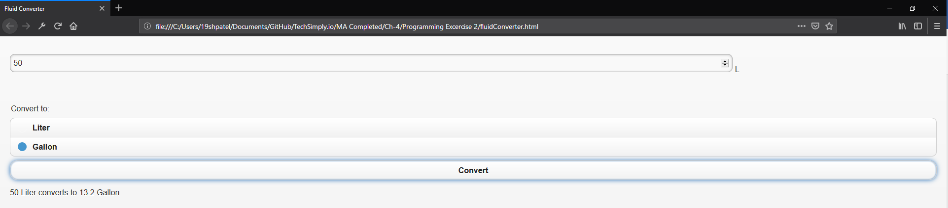

Figure 5 Validation Website

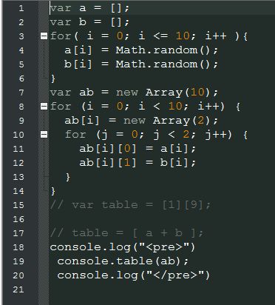

Figure 6 Javascript for arrays

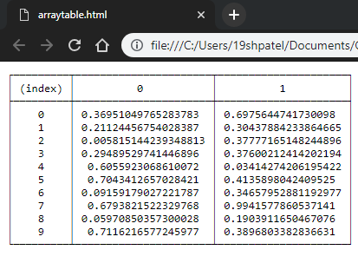

Figure 7 Array Website

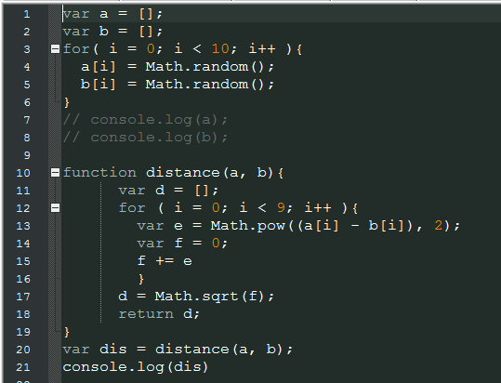

Figure 8 Javascript code for Math Function

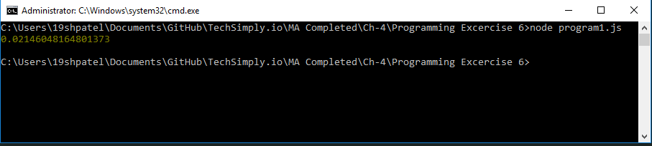

Figure 9 Command Line Output for Math functions

Ch-5

In chapter 5, I learned how to create password protected pages, work with updated jQuery and how to create links between different pages using anchors. I also learned that the jQuery code for the book was outdated, so I updated it to latest version compatible with the latest version for jQuery mobile. I also learned that jQuery mobile has compatibility issues with the latest jQuery and that it is not maintained as regularly as the main jQuery.

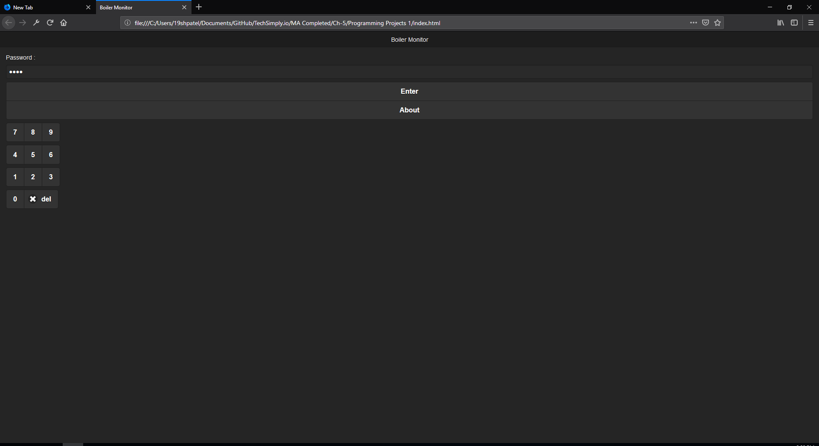

Figure Home Page



Figure User Information Page



Figure Menu Page

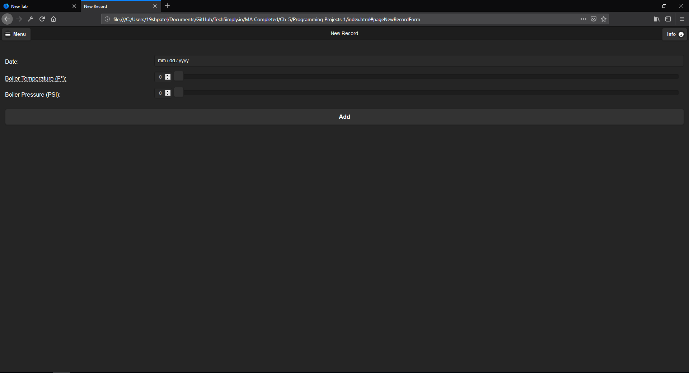

Figure Records Page

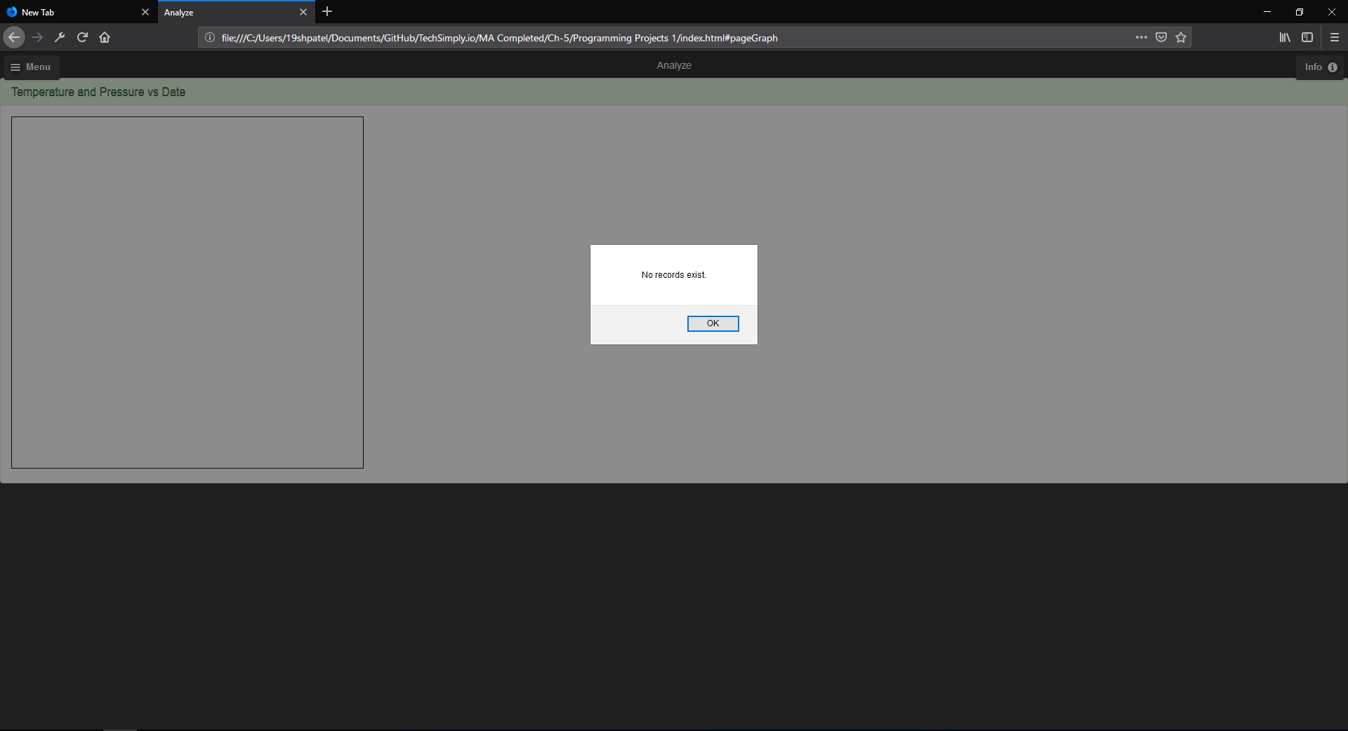

Figure Graph Page

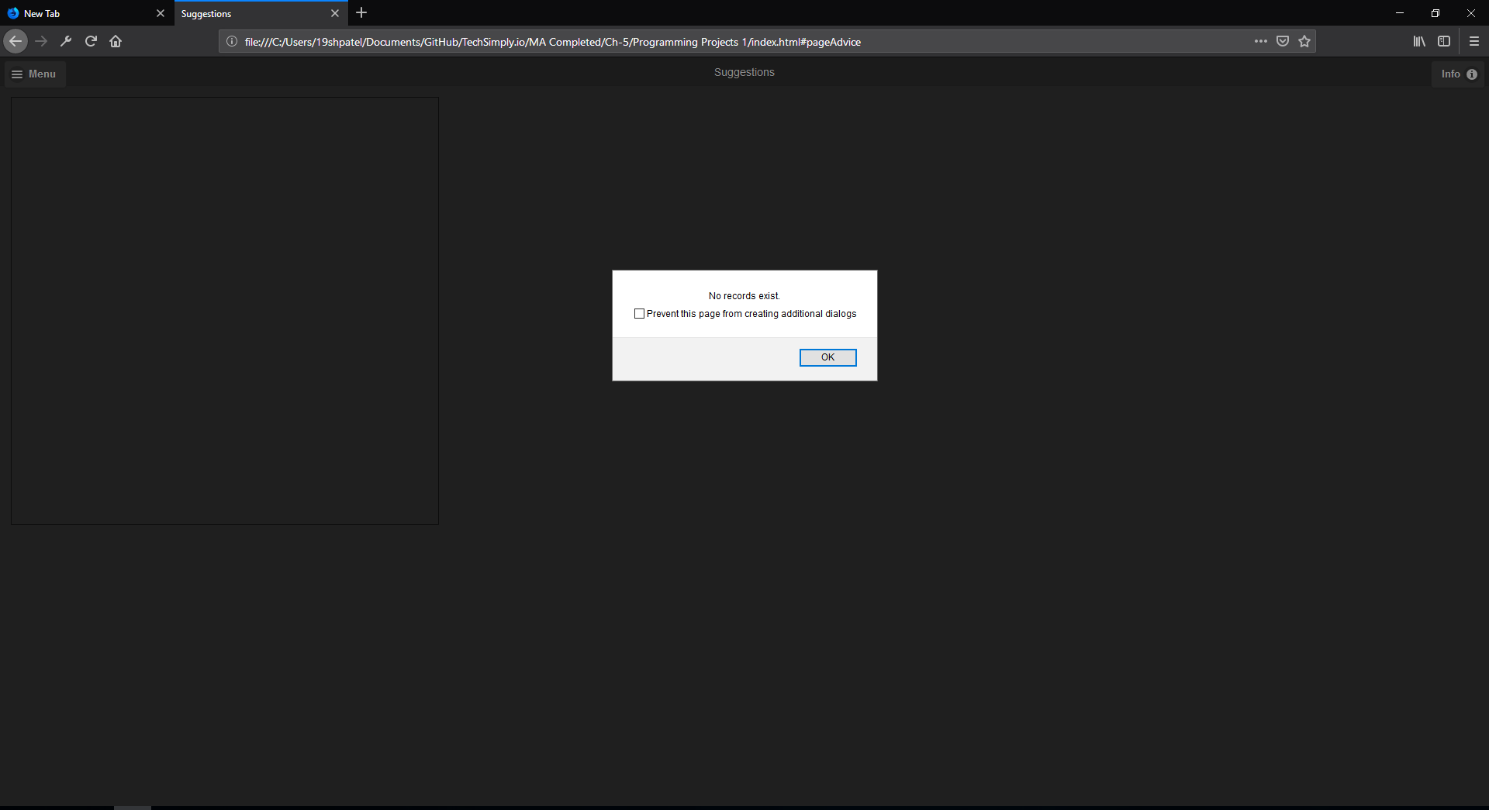

Figure Suggestions Page